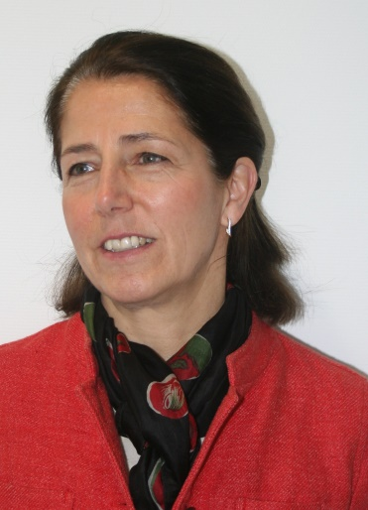
Dr. Susanne Zänker
A.I.S.E. Director General
Dr. Susanne Zänker has been Director General of A.I.S.E., the International Association for Soaps, Detergents and Maintenance Products, since August 2005. As head of the Association and based in Brussels, she leads the A.I.S.E. Team and the membership, consisting of 29 national associations, 17 corporate members and 9 value chain partners across Europe. She interacts with stakeholders on a daily basis in spearheading the industry agenda.
Dr. Zänker graduated as a Doctor in veterinary medicine at the University of Liège, Belgium in 1989. In 2016, she also received an Executive Masters in International Association Management at the Solvay Business School (ULB) of Brussels.
After 1 year in academic research for a EU Commission project on rabies, Susanne joined in 1990 Boehringer Ingelheim Vetmedica GmbH in Germany as Product Manager for vaccines. In 1993, she moved to the European Federation for Animal Health FEDESA (now known as AnimalHealth Europe), where she became Technical and International Affairs Director in 2000 and Managing Director in 2004.
Susanne is the author of several scientific publications and was a speaker at numerous international symposia and congresses on animal health until 2005. Today, Susanne is proactive in presenting updates on key developments for the detergents industry in Europe at major events and conferences on behalf of A.I.S.E..

