Up-dating the A.I.S.E. statistical data management and
interpretation tool for Excel 2007

- Open de file.
Go to the “Data” Sheet
Insert the “developer-tab” selecting “Show Developer tab in the Ribbon” in the “Popular” part of the “Excel Options”.
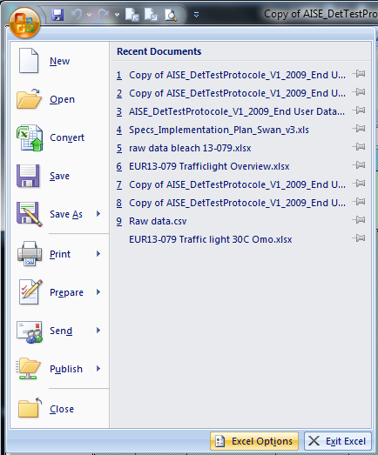

- Go to the Developer-tab and press the “view code”-button. 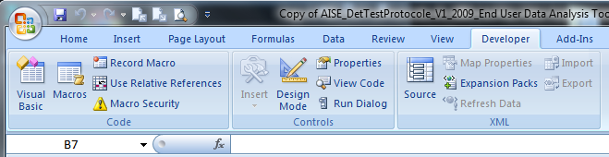
The Visual-basic screen will appear containing the macro’s that runs the template.

- Select Step 4 and
- Insert the sentence:
Sheet5.Visible = True
- Change the sentence:
Sheet5.[A:VI].Clear into Sheet5.[A:IV].Clear
Do this in the exact same place as shown in the picture.
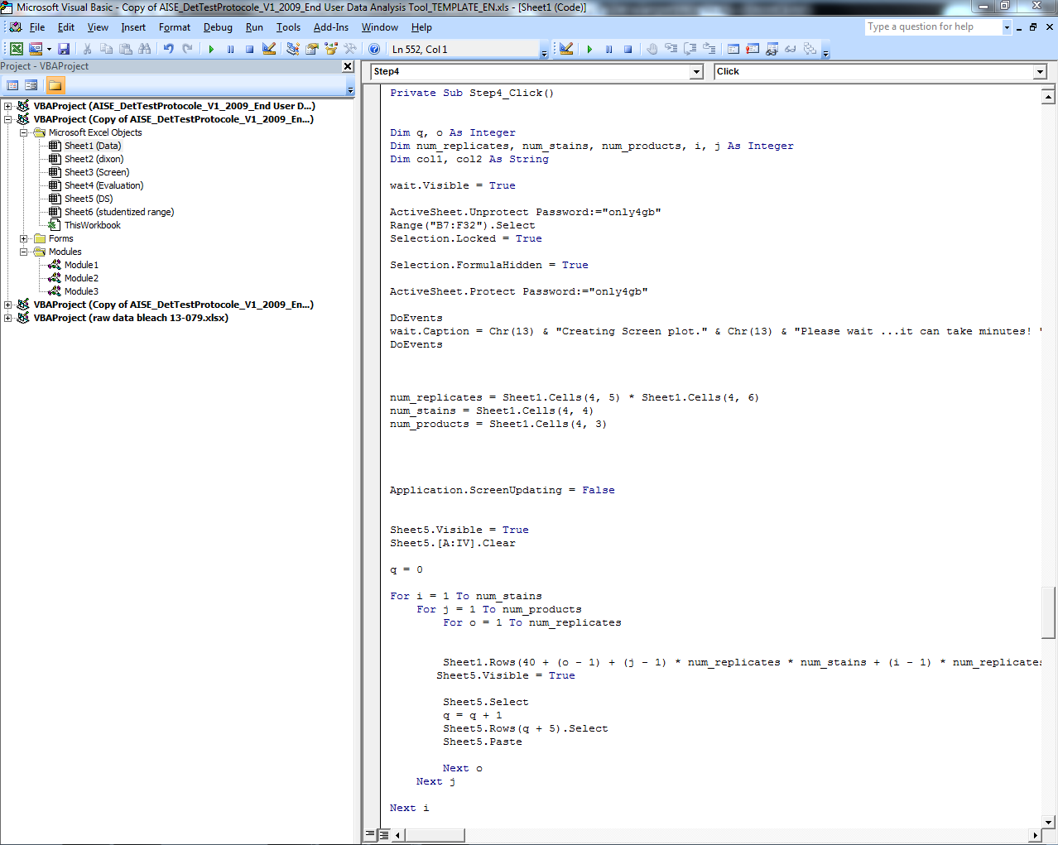

- Press “page down” 1 time on your key-board.
- Insert the sentence:
  - Select_confidence.Show
Do this in the exact same place as shown in the picture.
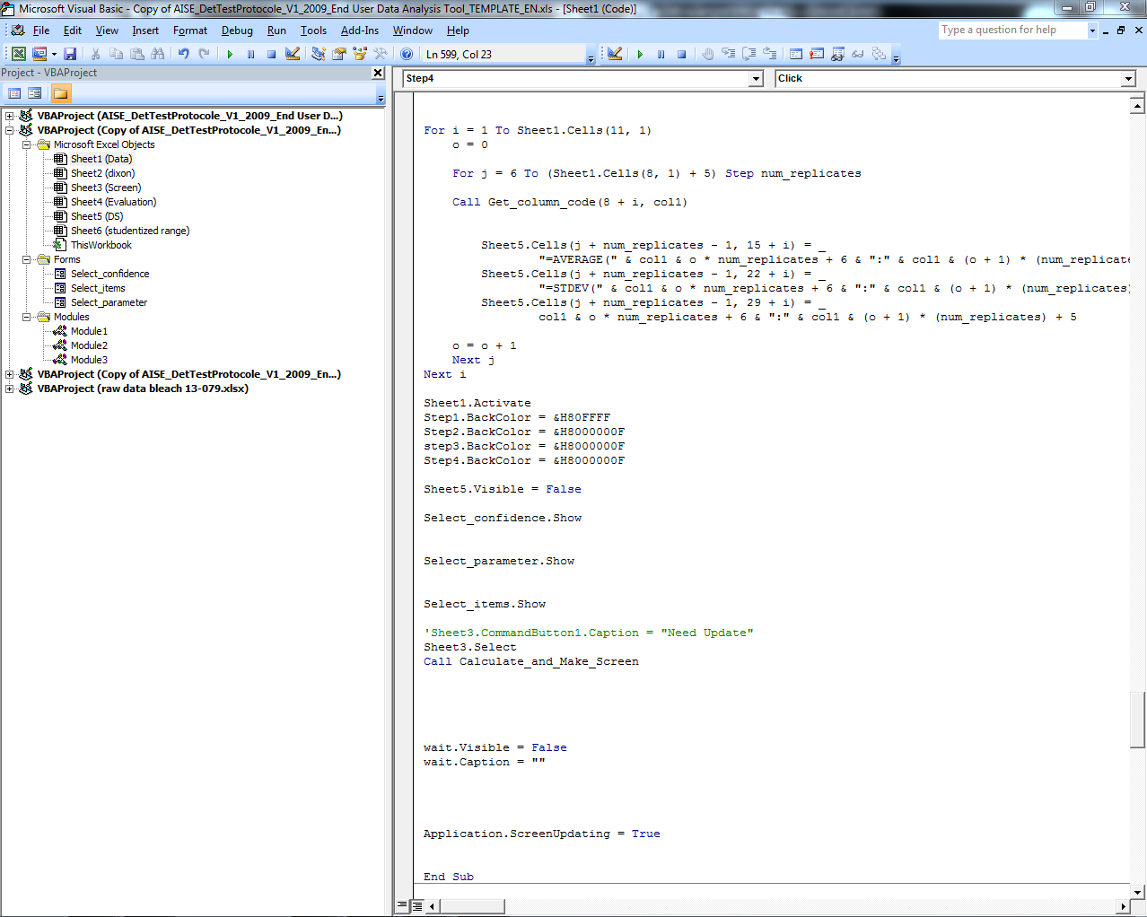

- Select Module 1 and select Calculate_and_Make_Screen
- Change the sentence:
For i = count_s To 3 Step -1 into For i = count_s – 2 To 1 Step -1
Do this in the exact same place as shown in the picture.
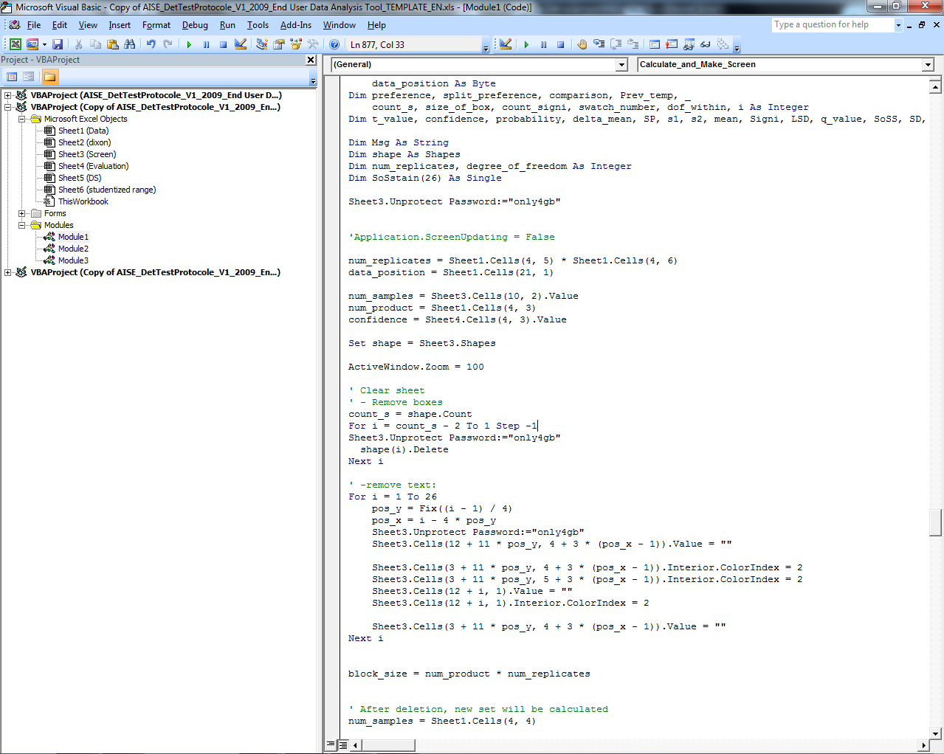

- Press “page down” 2 times on your key-board.
- Insert the sentence:
  - Selection.ShapeRange.Line.Weight = 1.5
Do this in the exact same place as shown in the picture.
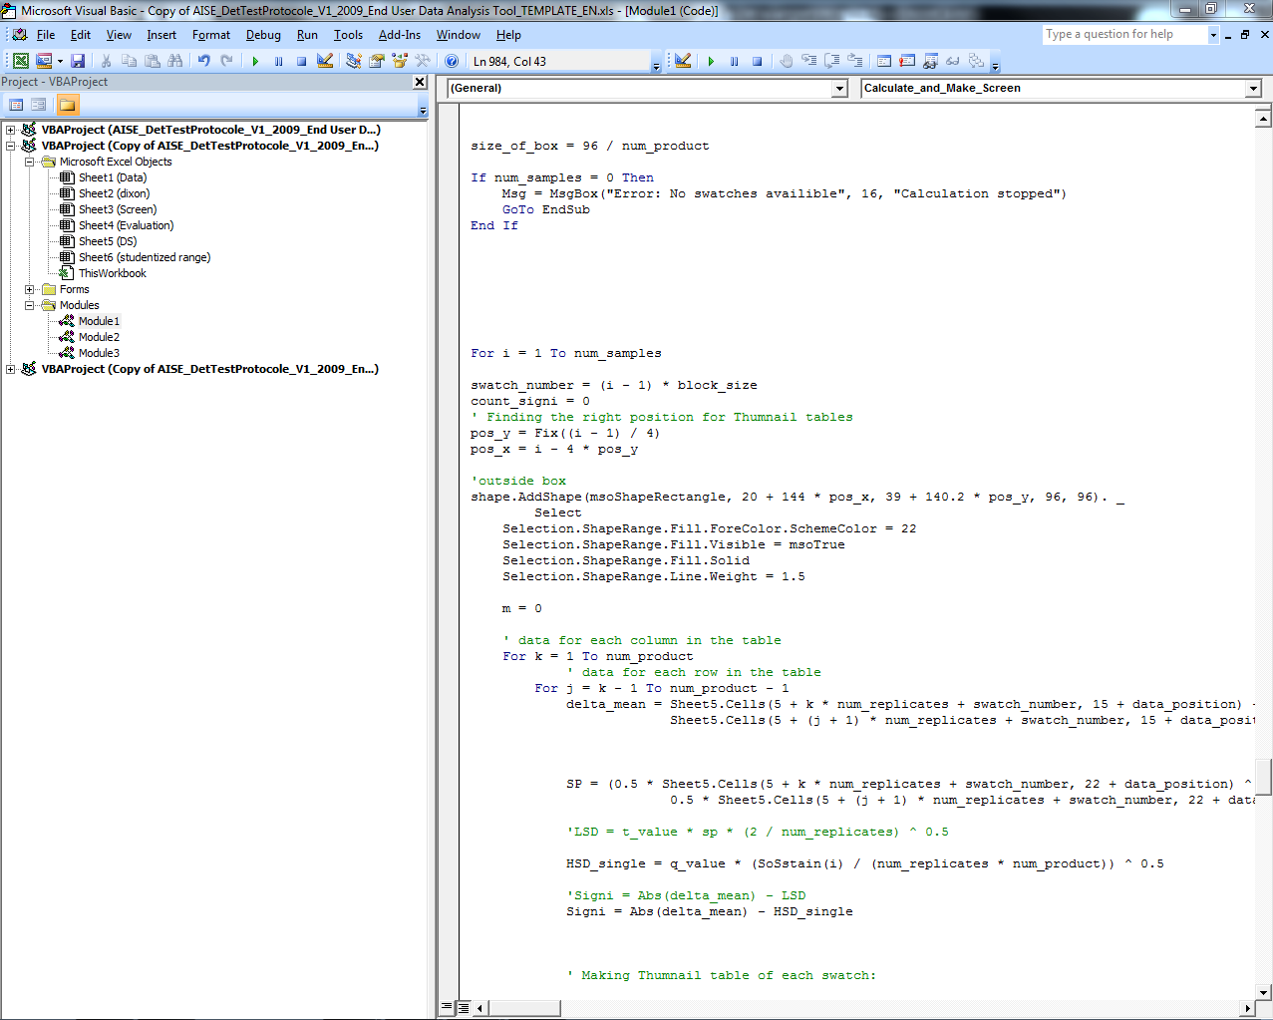

- Press “page down” 1 time on your key-board.
- Insert the following sentence in 6 places:
  - Selection.ShapeRange.Line.Weight = 1.5
Do this in the exact same places as shown in the picture.
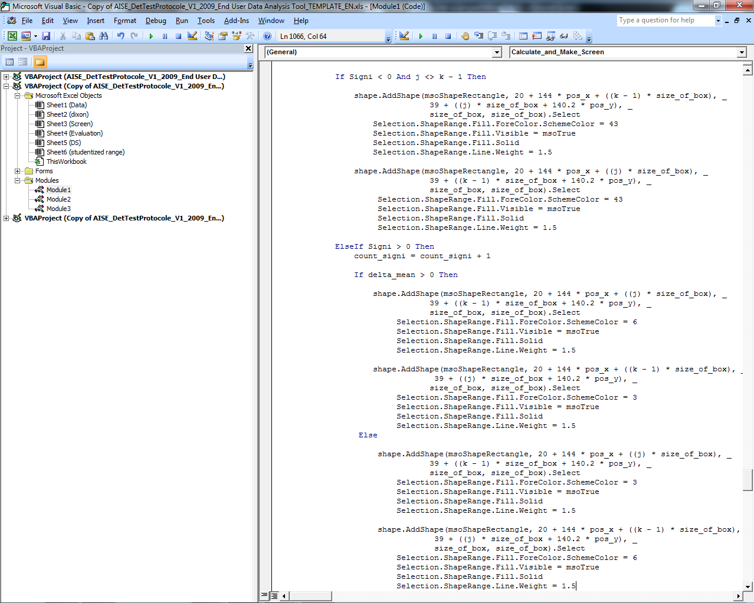

Close the Visual-Basic application by clicking the cross in the top right corner. You will return to the tool in excel. Save the tool and the now it is ready to use again.

Enjoy using the AISE statistical data management and interpretation tool !!!

