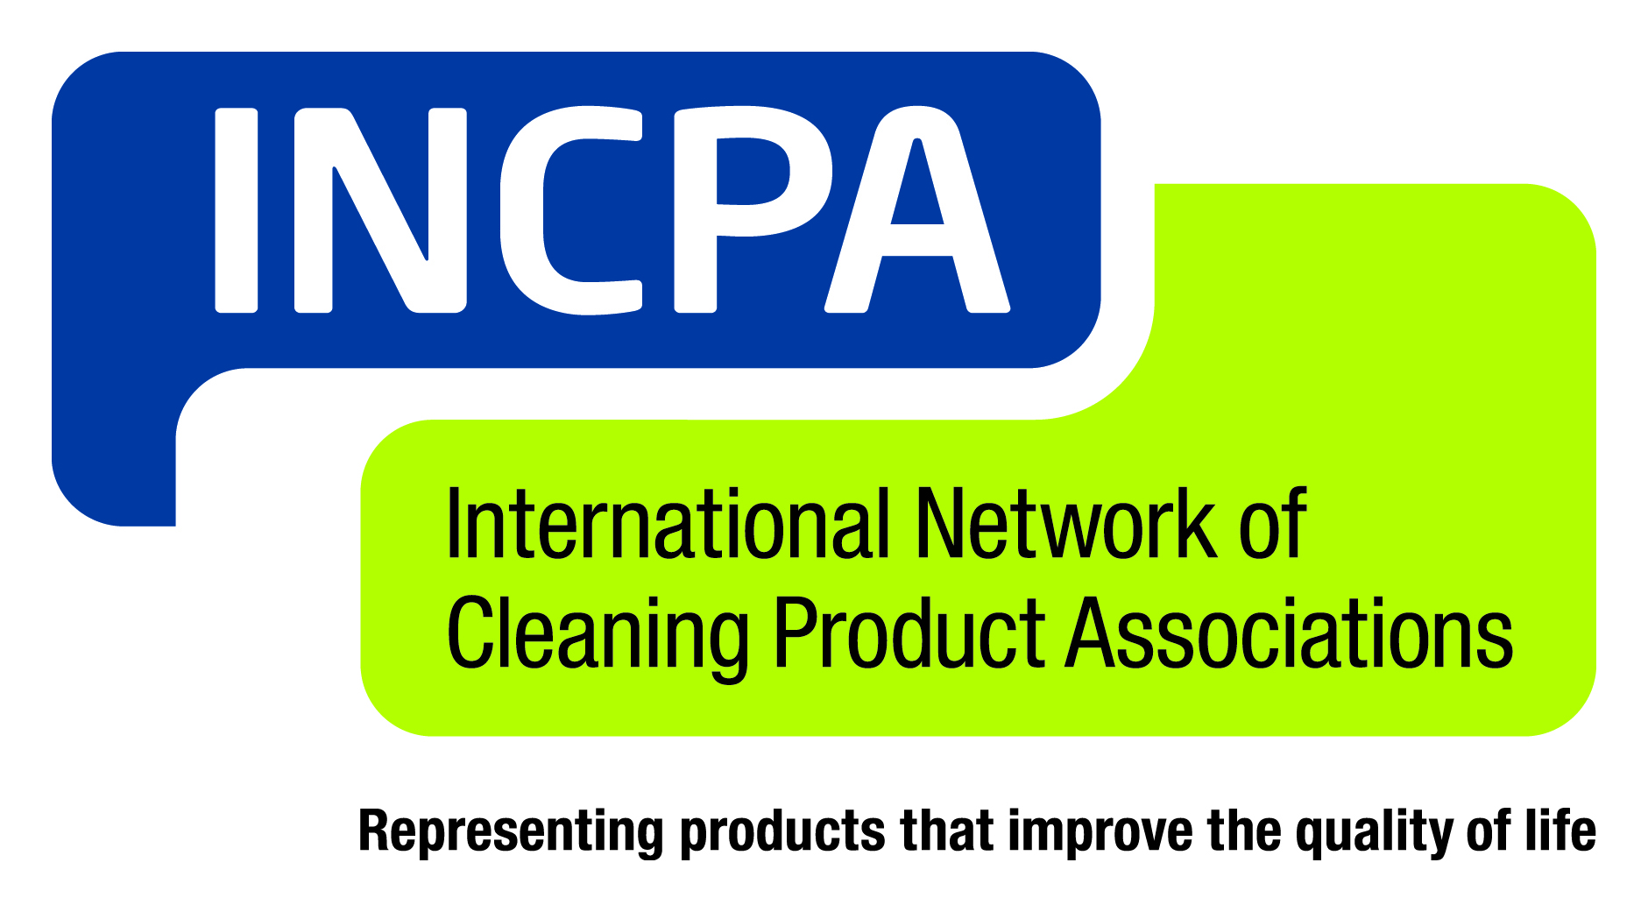
Contact: Brian Sansoni, American Cleaning Institute, 202.662.2517 or bsansoni@cleaninginstitute.org

International Cleaning Product Network Welcomes Indian,
Mexican Associations to Membership

- International Network of Cleaning Product Associations (INCPA) Launches New Web Portal, Showcases Worldwide Partnerships at World Conference on Fabric & Home Care

Montreux, Switzerland, 6 October, 2014 – The International Network of Cleaning Product Associations (INCPA) welcomed two new member organizations – representing the Indian and Mexican marketplaces – as global cleaning product industry leaders gathered at the World Conference on Fabric and Home Care in Montreux, Switzerland.

INCPA also unveiled a new web portal – www.incpa.net – integrating the websites of the world’s leading cleaning product trade associations, featuring a new compilation of industry best practices on health and safety, sustainability and consumer issues.

INCPA is a coalition of trade associations located in various regions of the world that represent cleaning product formulators, including Australia, Brazil, Canada, Europe, Japan, and the United States. The Network coordinates and actively engages in targeted efforts to better understand and address issues of an international or a cross-regional nature that affect the cleaning products industry.

The two new member organizations of INCPA are the Mexican Personal and Home Care Industry Association (CANIPEC) and the Indian Home & Personal Care Industry Association (IHPCIA).

“Bringing the Mexican and Indian associations into the Network strengthens our ability to share information, expertise and knowledge on the key issues affecting the global cleaning product marketplace,” INCPA leaders said in a statement. “INCPA member organizations serve economies totaling over 2.7 billion people, with the market value of their member companies’ products totaling $130 billion (USD).”

Updated INCPA Website Provides Portal to Cleaning Associations Worldwide

The updated website – www.incpa.net – provides visitors with an intuitive, more visually appealing platform to INCPA’s members, which, in addition to the new member associations, include:

- ABIPLA - Brazilian Cleaning Products Industry Association: www.abipla.org.br
- ACCORD Australasia: www.accord.asn.au
- ACI - American Cleaning Institute: www.cleaninginstitute.org
- A.I.S.E. - International Association for Soaps, Detergents and Maintenance Products, Europe: www.aise.eu
- CANIPEC - Mexican Personal and Home Care Industry Association: - www.canipec.org.mx
- CCSPA - Canadian Consumer Specialty Products Association: www.ccspa.org
- CSPA - Consumer Specialty Products Association, United States: www.cspa.org
- IHPCIA - Indian Home & Personal Care Industry Association: www.ihpcia.org
- JSDA - Japan Soap and Detergent Association: www.jsda.org/w/e_engls/
Association contacts for INCPA activities are as follows:

ABIPLA: Eugenia Maria Proenca Saldanha - eugenia@abipla.org.br

ACCORD Australasia: Bronwyn Capanna - bcapanna@accord.asn.au

ACI: Richard Sedlak - rsedlak@cleaninginstitute.org

A.I.S.E.: Susanne Zänker - susanne.zaenker@aise.eu

CANIPEC: Carlos R. Berzunza Sánchez - direcciongeneral@canipec.org.mx
CCSPA: Shannon Coombs - coombss@ccspa.org

CSPA: Tim Brown - tbrown@cspa.org
IHPCIA: Sanjay Trivedi - strivedi@ihpcia.org

JSDA: Tsutomu Katagiri - katagiri@jsda.org

###
The International Network of Cleaning Product Associations (INCPA – www.incpa.net) is a coalition of trade associations located in various regions of the world that represent cleaning product formulators. The Network coordinates and actively engages in targeted efforts to better understand and address issues of international or cross-regional nature that affect the cleaning products industry.
Cleaning products are essential to society. INCPA members are committed to developing, manufacturing, distributing, and marketing innovative, sustainable and effective products that are safe for consumers and the environment. The Network’s members are committed to the development of products that improve the quality of life through hygiene and cleanliness, can be used safely and without unreasonable risk to the environment, and fulfill the principles of sustainability, as well as meeting or exceeding legal requirements.

