LETTER OF PARTICIPATION/COMMITMENT FOR COMPANIES TO
THE A.I.S.E. AIR FRESHENERS STEWARDSHIP PROGRAMME
(Version 3.2, 4 October 2007)

A COMMITMENT by
(“the Company”) with a principal place of business at

(“Address Headquarters”) to the A.I.S.E. Air Fresheners Stewardship Programme (“the Project”) of the Association Internationale de la Savonnerie, de la Détergence et des Produits d’Entretien AISBL with its registered office at Boulevard du Souverain 165, 4th floor, 1160 Brussels, Belgium (“A.I.S.E.”), dated _________________, 200__

WHEREAS

A.I.S.E. has engaged into promoting sustainability and communication on best and safe use of products to consumers through a series of voluntary initiatives;

A.I.S.E. has the view that these voluntary initiatives should be extended to Air Fresheners which have become an important product category used by an ever increasing number of consumers in their daily life to help improve its quality and comfort;

A.I.S.E. is willing to further enable consumers to make best-informed choices for a safe product usage, as it is willing to enhance cooperation with authorities, including at EU level, and NGOs;

A.I.S.E. has set up a voluntary industry initiative aimed at Air Fresheners, the A.I.S.E. Air Fresheners Stewardship Programme (“the Project”);

The aim of the Project is to promote responsible consumer communication as well as the adoption of technical standards for specific Air Fresheners;

It is a fundamental part of the A.I.S.E. policy, and as such this Project, to act always in compliance with all applicable laws, in particular with competition law, in pursuing its goals. In pursuing this project A.I.S.E. and the Company shall endeavour to always act in strict compliance with competition law and shall specifically observe the current A.I.S.E. Competition Law Compliance Guidelines (currently dated 22 September 2005);

The Company has applied to the A.I.S.E. to be recognised as being a participant to the Project and has agreed to make the commitment set out below;

The A.I.S.E. is satisfied that the Company manufactures and/or places on the market in Europe (EEA + Switzerland) air fresheners products among the following categories: sprays (including aerosol – mini and pump-sprays), perfumed candles, liquid wick, gel, potpourris, electrical devices, car fresheners, incense (“the Products”) and as such meets the Eligibility Requirements of the Projects;

The Company HEREBY COMMITS (“Commitment”) to the Project in respect of its Air Freshener operations (“Operations”) placed onto the European market (EEA + Switzerland).

WHEREBY the Company shall
- Strive to meet the objectives of the Project;
- Implement all elements set out in the Company’s commitment as set out in Annex 1 and which covers legislation, product label information, responsible communication, use of standards;
- Strive to do nothing that may be detrimental to the aims of the Project or that may bring the Project, fellow Project participants, A.I.S.E. or its members into disrepute;
- Endeavour to always act in strict compliance with competition law, all relevant legislation, and internationally recognised guidelines and standards (e.g. WHO, IFRA/EFFA for fragrances).

This Commitment shall remain in full force and effect until either terminated a) by the Company at any time serving not less than six (6) months prior written notice upon the A.I.S.E. of it withdrawing its subscription to the Project or b) by A.I.S.E. serving not less than 6 months prior written notice upon the Company following the Company’s failure to meet material requirements under the Project and/or this Commitment, provided, however, that A.I.S.E. must provide the Company with written notice to the Address Headquarters specifying the Company’s material failure or material breach.

If such failure and/or breach is cured by the Company within sixty (60) business days from receipt of such notice the termination by A.I.S.E. for the respective failure or breach shall be null and void.

Any Company dissatisfied with any decision of A.I.S.E. in relation to the Project, which may prejudice its interests, may refer the matter to the A.I.S.E. Board who will render a decision, after considering the Company's representations.

This Commitment and the rights, duties and responsibilities of the Company and A.I.S.E. under the Project shall continue in full force and effect during any notice period.

…………………………………………………………………………………….. …………………
(Signature) Authorised to sign on behalf of the Company (Date)

……………………………………………………………………………………..
(Name)

……………………………………………………………………………………...
(Position)

Annex 1

The Commitment

1) Product labels

The Company shall ensure that Product labels are designed and labeled according to the following rules:

- good visibility to be ensured through:
- A good graphic/visual contrast between text and background
- Key safety messages to be clearly indicated (e.g. via use of a text box. See examples in Annex 3).

- Health related information in label statements:
- Where relevant and applicable, clear advice for safe usage of the Product including maximum exposure;
- Where applicable and following national requirements, inhalation abuse warnings for sprays using solvents and propellants;
- The two following sentences shall be added to the labels:
- “People suffering from perfume sensitivity should be cautious when using this product”
- “Air Fresheners do not replace good hygiene practices”.

The Company shall refrain from using the absence of banned materials in a Product as a marketing claim (e.g. "without CFC").

2 ) Information to be provided following Regulation 648/2004/EC on Detergent
The company shall make all information on the ingredients composition of the Product from 100 ppm available - according to Regulation 648/2004/EC - to the consumers via a corporate website using INCI names. The website address shall be put on the product label.

In addition, an ingredient datasheet as per annex VII C of Regulation 648/2004/EC shall be provided upon request; contact details where to request the medical information shall also be put on the Product label.

3) Product shape:
The Company shall not manufacture and/or put on the market toy-shape Products specifically intended to attract children. According to Directive 88/378/EEC on the safety of toys, a 'toy' shall mean “any product or material designed or clearly intended for use in play by children of less than 14 years of age.”

4) Advertising:

The company shall not show young children activating the Product.

The company shall not promote the Product by advertisements involving pregnant women or babies.

The company shall demonstrate appropriate use and product handling in compliance with product labeling when advertising.

All Product claims shall be substantiated.

5) Additional provisions regarding Combustion Products
a) Combustion with flame
Where the Company manufactures and/or places on the market a combustion Product with flame, i.e. perfumed candles, it shall, in addition to complying with the Dangerous Preparations Directive 1999/45/EC and all relevant legislation, adopt the latest relevant CEN standards (currently under development: sooting behaviour (prEN 15426.2007), fire safety (prEN 15493.2007) and product safety labels (prEN 15494.2007) (4 warning messages)).

b) Combustion without flame
Recent studies on air fresheners and incense point out that incense, either used in cones or sticks, present high emissions of combustion by products, which could be of concern due to some of the substances which are released through combustion.

The Company shall therefore apply the precautionary principle with regards to the incense cones and sticks which it manufactures and/or places on the market, on basis of a careful scientific risk assessment.

6) Companies’ communication on commitment
Should a company wish to communicate on its participation to the Project, any corporate communication shall use the exact following wording: “Company [name the Company] has committed to the A.I.S.E. industry initiative Air Fresheners Stewardship Programme.” Any use in electronic corporate communication materials must include a link to the Programme Stewardship website www.aise.eu/airfresheners.

No reference shall be made to the product brand performance.

Annex 2

Examples of key safety messages

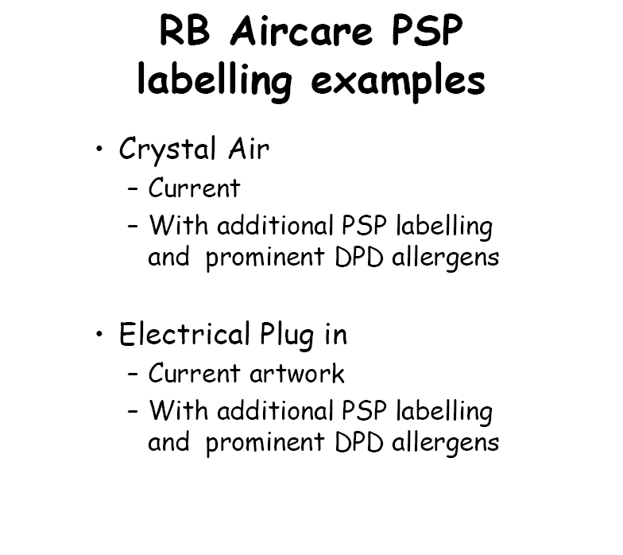

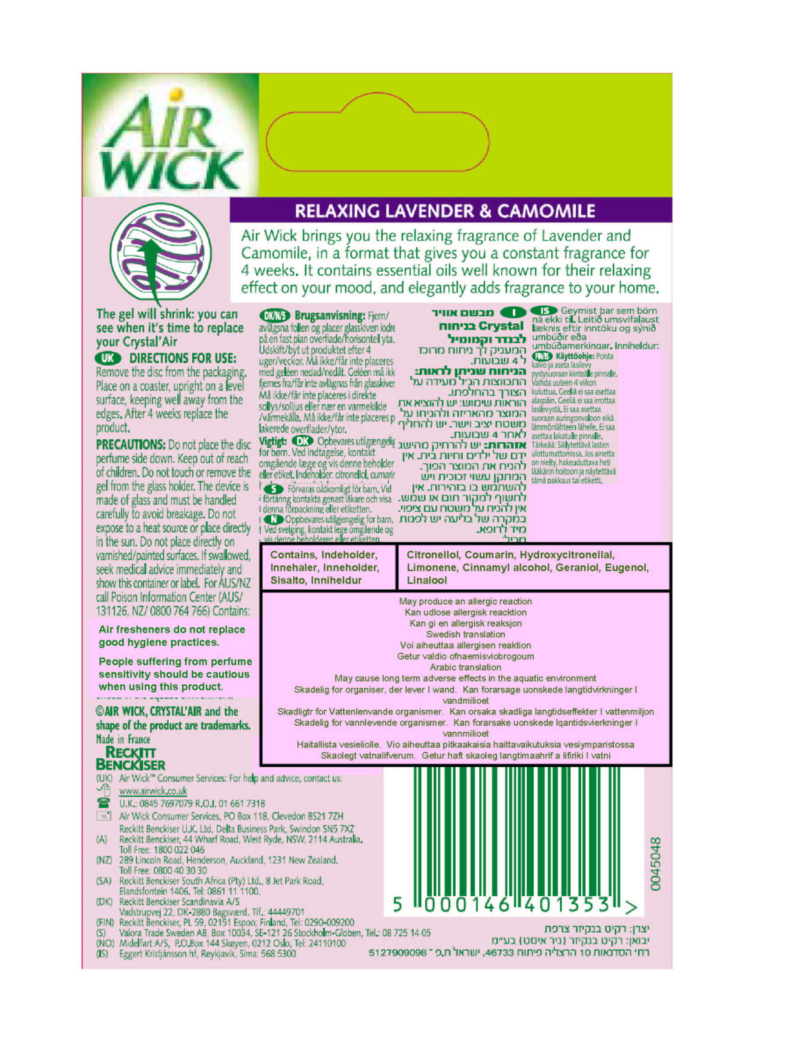
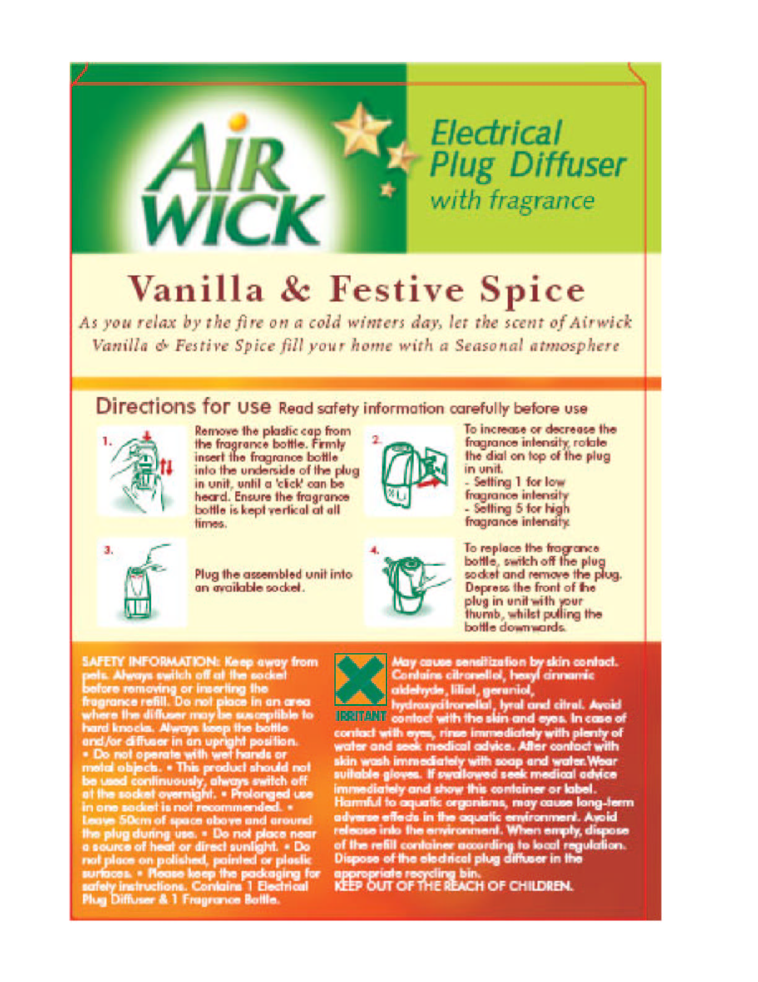
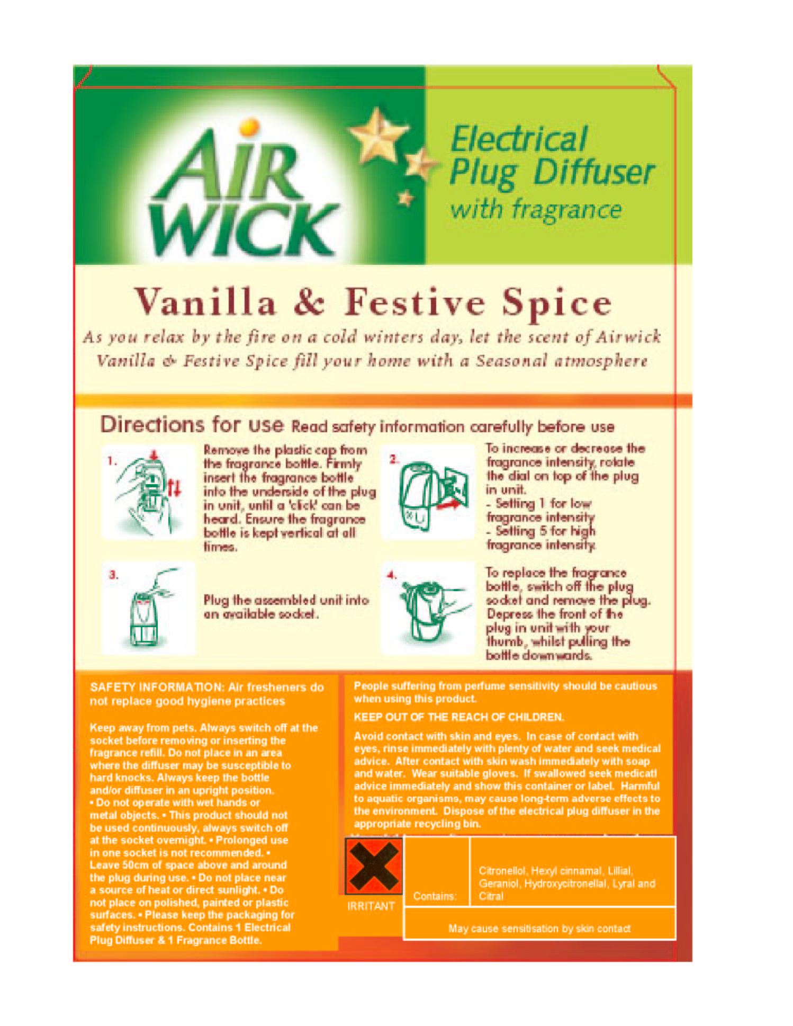

A.I.S.E will provide proper translation in all EU official languages for consistent use.
More specific information related to effects of products on perfume sensitivity and onto precautions to take regarding use can be provided on corporate website.
SCHER report adopted on 27 January 2007: Opinion on the report “Emission of chemicals by air fresheners –Tests on 74 consumer products sold in Europe. BEUC report January 2005”. Spruyt M, Poelmans D, and Goelen E, September 2005. Emissions from a set of air fresheners, 2005/MIM/R/108, VITO. Spruyt M, Bormans R, Geyskens F, Poelmans D, Verbeke L, Goelen E, March 2006. Influence of air fresheners on indoor air quality, 2006/MIM/R/032; VITO, Research Unit Environmental Measurement. Belgium : Arrêté ministériel portant interdiction de certains cônes et bâtonnets d’encens of 7 January 2005. Published on 01.11.2005. Prolongation until 31 January 2006 by arrété ministériel of 20 Juillet 2005, published on 29.07.2005.

