liquid laundry detergents capsules
Industry statement | 15 January 2018

The detergent industry is deeply concerned about the recent trend in social media to intentionally promote the misuse of liquid laundry detergents capsules. The industry considers it as an extremely dangerous practice, which should not be promoted in any way.
This trend, coming from the US, should not be encouraged or repeated in any way, as this behavior may result in serious injuries.
Liquid laundry detergent capsules are safe when used as intended and as specified on the product packaging. They should be only used to clean clothes and stored safely: on a high shelf and/or in a locked place, with the pack closed and away from children.
Manufacturers of liquid laundry detergent capsules provide guidance on all their packs via a yellow patch (see figure 1 below) and through proactive communication campaigns such as the pan-European A.I.S.E. “Keep Caps From Kids” initiative, including the multi-lingual website www.keepcapsfromkids.eu (see figure 2).
A.I.S.E.’s “Keep Caps From Kids” initiative is supported by the European Child Safety Alliance and more than 20 partners in Europe from Ministries, Poisons Controle Centers, and safety associations.

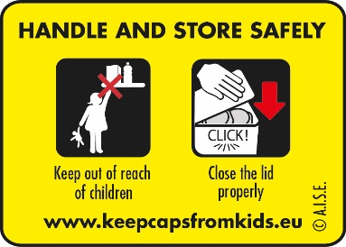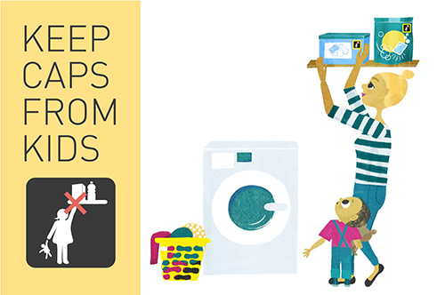
Figure 1 (left): The above yellow patch is found on all packs of liquid laundry detergents capsules and consistently used by the sector since 2013 to alert parents and caregivers and promote the safe use of these products.

Figure 2 (right): The online media campaign “Keep Caps From Kids” has reached more than 97 Mn European consumers in 2014. The website www.keepcapsfromkids.eu provides useful tips, in all EU languages, on how to handle and store safely liquid laundry detergent capsules.

For more info about A.I.S.E. activities:

http://www.aise.eu/our-activities/product-stewardship-programmes/liquid-detergent-capsules.aspx

Please contact M. Temsamani, External Affairs Manager
mohamed.temsamani@aise.eu
0032 2 679 20 15

Roberto.scazzola@aise.eu

