Charter Performance section 2017 Report

KPI Highlights (2016 vs 2015)

Charter footprint and production
Unchanged compared to last year, 100 companies submitted their KPI data. The total production tonnage covered by the Charter including new companies joining was 11.7mt, equivalent to 99.3% of the total output of reporting companies in the EU+4.

Energy consumption
Total energy consumed decreased by 6.6% on a like-for-like basis, confirming the trends over the last four years.

CO₂ emissions
Total emissions of CO₂ fell again by 7.2% on a like-for-like basis

Change since 2006
Energy use per tonne of production is down by 34.9% and CO₂ by 30.6% over the 11 years since 2006

Advanced sustainability
The number of consumer products carrying the Advanced Sustainability Profile (ASP) logo increased from 1.29 billion to 1.41 billion units, an increase of 9.3% on a like-for-like basis. From the laundry category alone, 41% of products comply with the Charter Advanced Sustainability Profiles. Since 2011, European consumers bought 5.41 billion Charter ASP products.

Introduction
The Key Performance Indicators (KPIs) shown in the table on page 8/9 of the A.I.S.E. Activity and Sustainability Report 2016-2017 include the results for 2016 alongside those for earlier years.

KPI data are submitted by the Charter Ordinary Member companies to Deloitte which manages the data collection process, and the aggregated results are then provided to A.I.S.E. The companies submit their data for their twelve month financial or sustainability reporting periods ending during the calendar year. In addition to this third-party data collection and aggregation, the company data reports are subject to an independent veriﬁcation process conducted by the international audit firm SGS on behalf of A.I.S.E.

Associate Members, which are not manufacturers but are importers, distributors or retailers placing products on the market under their own labels, do not report KPI data directly but contribute any relevant information to the submissions made by the Ordinary Members which are the contract manufacturers of those products.

Charter version
The first upgraded version of the Charter was introduced in 2010. This upgrade added an extra product dimension to the Charter which enables companies to use an enhanced logo design to indicate when products meet certain advanced sustainability profiles (ASPs). One consequence of this 2010 upgrade was an additional KPI reporting requirement, namely to report the number of products carrying the enhanced ASP logo.

As at December 2016, 95% of manufacturing companies had migrated to the Charter 2010 update. This report covers results for both Charter version 2005 and migrated Charter update 2010 companies.

‘Charter Area’
The term ‘Charter Area’ in this report refers to the EU and EFTA member states as at 31 December 2016, namely the EU 28 plus Iceland, Liechtenstein, Norway and Switzerland.

Charter footprint
Unchanged compared to last year, 100 companies submitted their KPI data.

This number refers to the headquarters of Ordinary Member companies signed up to the Charter. In terms of manufacturing sites included in the 2016 reporting, the total decreased slightly to 178. The KPIs are estimated to cover around 90% of all household, cleaning and maintenance production in the Charter Area.

There was an increase in the number of Associate Members joining the Charter during 2016, from 126 to 130. This trend confirms the continuing support of retailers, distributors and importers for the industry’s drive to improve sustainability.
Since the launch of the Charter in 2005, there have been five withdrawals from membership to date, and there have been eleven consolidations resulting from mergers.

Comparability

As mentioned in earlier years the steady increase in the reporting base means that the results are becoming more reliable, nevertheless direct comparisons between the years, especially the earlier years, should be made with care. From 2006 onwards year-on year comparisons can be considered broadly reliable.

It should also be noted that small companies tend to have manufacturing profiles which differ from those of the multinationals, and as a consequence there can be increases or decreases in the overall KPI results which reflect such differences to a greater extent than any underlying change in performance.

Multinationals and SMEs

Some clear underlying differences in performance emerge between the large multinational companies and the small and medium enterprises. These differences are not visible in the data provided because all the figures are aggregated.

Tonnage production
The total production output of all companies in the Charter scheme was 11.7 m t, up from 11.4 m t in 2015. The proportion of that 11.7 m t represents 99.3% of the total output of the reporting companies, compared with last year’s 99.4%, and continues to mean the Charter is representative of the whole EU + 4 industry.

Consumer unit sales
The total number of consumer units sold by all Charter companies was 11.7 billion, a decrease compared with 2015 (12.0 billion).

Chemical safety evaluation


The proportion of chemicals covered by full HERA risk assessment was 71.9%, and there was a slight change year on year (73.5% in 2015). It is not expected that there will be any significant change in the future as the HERA programme is in effect completed. In due course the use of HERA assessments will be superseded by the REACH assessments which HERA was designed to pave the way for. HERA assessments cover the main high volume chemicals, and almost all manufacturers using these are now in the Charter. All chemicals used in the industry have recognised safety approvals; ‘safety evaluation’ in the context of the Charter refers to human and environmental risk assessments.

In the case of I&I companies the ratio of production sold for use under controlled dosing was stable at 0.4 m t (based on figures derived from SMEs and large companies).

Occupational health and safety
The average number of accidents per 100,000 hours worked during 2016 was 0.87 against 0.69 in the previous year. Overall, the long term average of below 1.0 is lower than the typical rate of 2.0 for all manufacturing industries and in line with the rate of 1.0 for the chemical industry. However the range is still wide, especially among small companies, and drawing too much significance from the year on year change should be avoided. One of the benefits of the Charter is to enable companies to benchmark themselves against the rest of the industry, stimulating improvement.

Consumer health and safety
The number of consumer contacts classified as real or perceived health-related enquiries, as a proportion of all consumer enquiries, has slightly increased to 1.6%. The expected range is 1% to 2%. The total number of contacts recorded is stable year on year, of which the number concerning product safety issues was up to 5.3%.

In the I&I sector the number of persons trained in safe handling has been stable at about 64,000.

Consumer response services
The number of dedicated consumer care lines or response services operated in the Charter Area was 806 compared with 788 last year. It is thought this number may be close to the maximum in relation to the total number of operating entities (1167) bearing in mind that some care lines are international covering more than one country.

Consumer and user information
There was an increase in number of units sold in the Charter area bearing at least two A.I.S.E. safe use icons to 6.8 billion, representing 58% of all consumer products sold by the Charter members. Usage of consumer best use information on-pack, encouraging sustainability at the consumer use stage, increased to 2.9 billion.

Poorly biodegradable organics


Charter members report their total purchases of the chemicals speciﬁed on a published A.I.S.E. list of ‘poorly bio-degradable organics’ (defined in Annex III of the KPI Detailed Explanation), as a proportion of total chemicals purchased. Compared to recent years, this rate stays stable at 2%.

Energy consumed
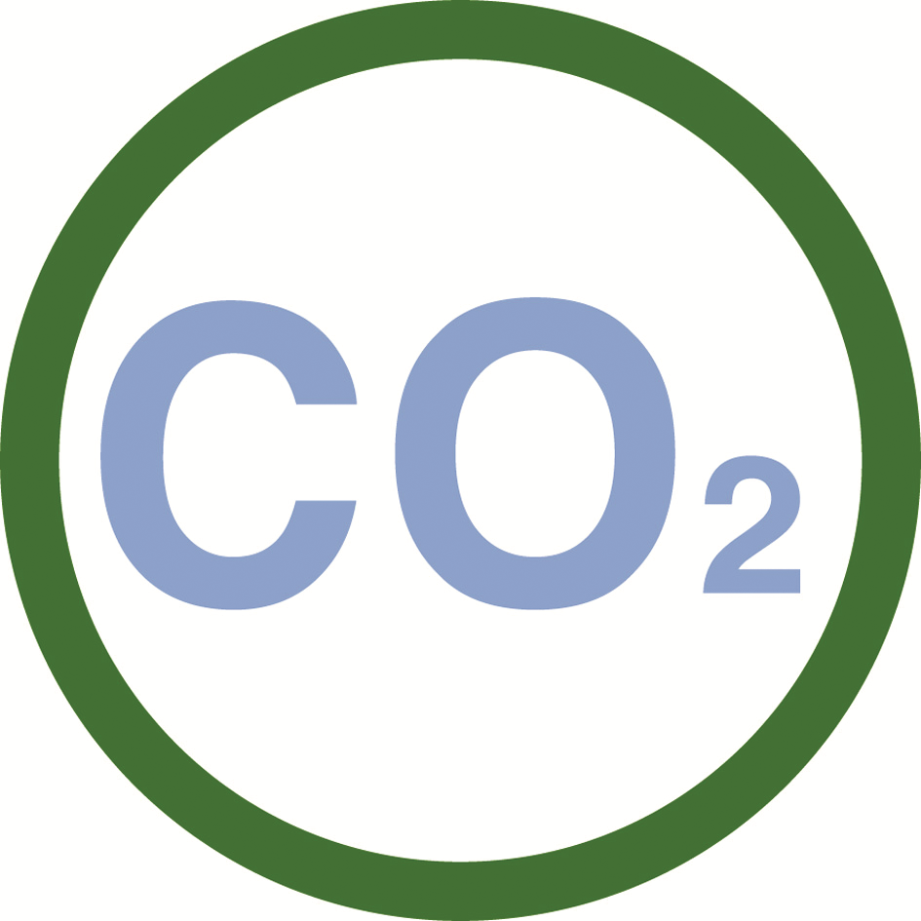
The total energy, expressed in GJ, consumed by the industry was 8.19 million against 8.66 million in 2014. Expressed as consumption per tonne of production, the energy consumed fell by 6.6% to 0.71GJ/tonne. Since 2006 there has been an overall efficiency improvement of 35.8% per tonne of production.

CO2 emissions

Expressed as emissions per tonne of production there was again a decrease, this year from 50.0kg to 46.4kg. Since 2006 there has been an overall reduction in emissions of 30.6% per tonne of production. The match with total energy consumed is not exact due to the fact that CO₂ emissions are variable depending on the mix of fuel used to generate energy. The trend of absolute decoupling of production from energy use and CO₂ emission continues getting stronger, demonstrated by the growing gaps between the curves of production vs. energy use resp. CO₂ emission as in the graph below.

The production is absolutely decoupled from energy use and C0₂ emissions
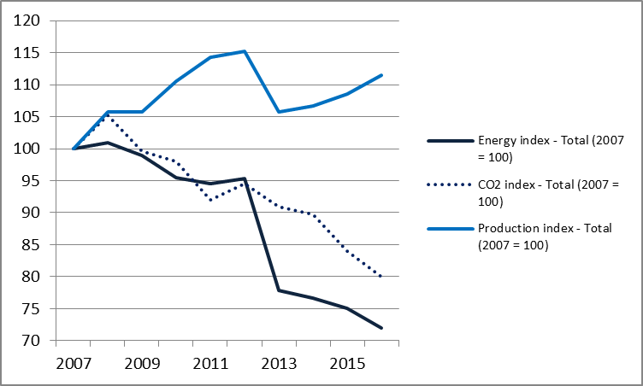

Waste and Hazardous waste

Total waste generated, including hazardous waste sent off site, went down to 11.7kg per tonne of production. The underlying rate of waste generation appears to be stable in the range 12kg per tonne. These figures are sensitive to site closures which can generate a one-off increase in waste as a consequence of de-commissioning.

Hazardous waste sent off site remains overall stable at 4.3kg per tonne of production. The ten-year average is around 4kg.

Consumed water
Total water consumed during manufacturing is stable at 1.2 m³ per tonne of production, remaining below the ten year average. Caution should be exercised in extrapolating a trend since water consumed is also a function of the mix of products manufactured.

Consumed Water (potable and non-potable) in m³/tonne of production
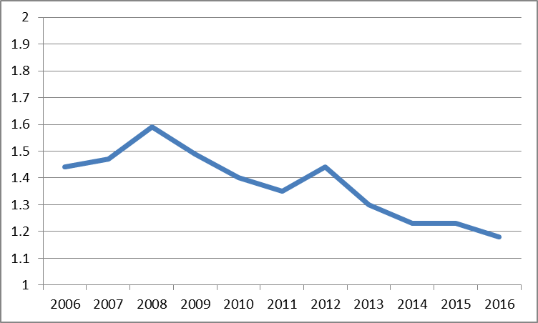

Packaging used
There was an decrease in total packaging material purchased from 92.6kg per tonne to 90.3kg. Compaction of products reduces the absolute weight of packaging required per pack, but on the other hand with compacted products the proportion of total pack weight attributable to the packaging is higher relative to the weight of the contents compared with un-compacted products. Thus when expressed per tonne the trend appears to be flat. When expressed in kg of packaging per thousand units (KU) of consumer products, the trend is clearly downward with a decrease from 105kg/KU in 2006 to 90kg/KU in 2016.

Product bearing the Charter ASP logo
In July 2011 the first “Advanced Sustainability Profiles” (ASP) categories were launched for laundry powders, laundry liquids and fabric conditioners, followed by automatic dishwashing detergents and dilutable all purpose and floor cleaners in 2013, trigger spray cleaners in 2014, manual dishwashing and toilet cleaners in 2015 (all household), and professional building care products in the same year. Since 2011, 5.41 billion ASP products have been bought by European consumers. Alone in 2016, this number was 1.41 billion, representing 20.5% of the concerned product category units sold during the year, and about 41% of laundry category units. Those figures can be broken down for each of the product categories as follows: 151 million laundry detergent powder products, representing about 25% of this segment, 411 million laundry detergent liquid products (32%), 706 million fabric conditioner products (58%), 44 million automatic (9%) and 27 million manual dishwashing products (2%), 53 million dilutable all purpose and floor cleaners (4%), and 18 million trigger spray cleaners (3%).
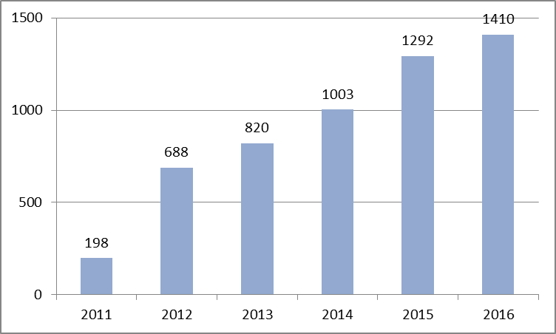
1.41 billion units of Charter ASP Products sold in 2016
Products with Charter 2010 ASP logo per product category
18m
Trigger spray cleaners
(representing 3% of the segment)
411m
Laundry detergent liquid products (representing 32% of the segment)
706
Fabric Conditioners (representing 58% of the segment)
44m
Automatic dishwashing products (representing 9% of the segment)
53m
Dilutable all purpose and floor cleaners (representing 4% of the segment)

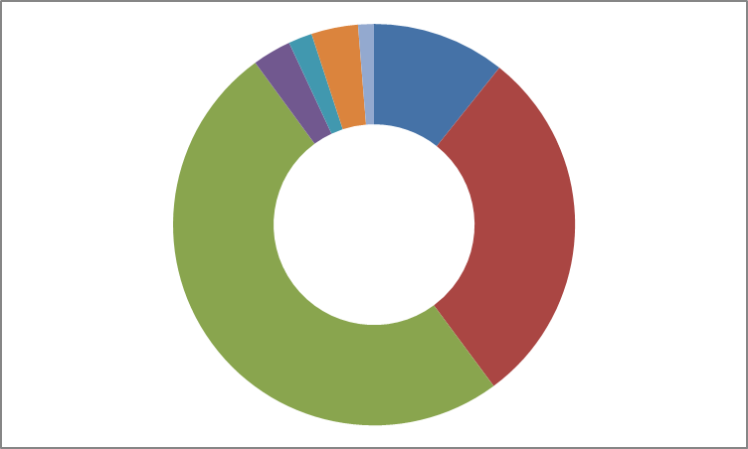
151m
Laundry detergent powder products (representing 25% of the segment)
27m
Manual dishwashing products (representing 2% of the segment)

17m
Trigger spray cleaners (representing 3% of the segment)

